Experiment 8: Online Learning Platform with Kano Model Prioritization in Jira
Course code: CSA1006
Course: Software Engineering
Name: B. Pavani
Register No: 192525248
Tool Used: Jira

Aim
To create an Online Learning Platform project in Jira, add its main features as tasks, and prioritize them using the Kano model (Must-be, Performance and Attractive).

Software Used
Jira Software (free plan), https://www.atlassian.com/software/jira

Concept of the Kano Model
The Kano model groups features by how they affect user satisfaction.
- Must-be: Basic features that users expect. The product is not acceptable without them, but having them does not delight users.
- Performance: Features where better quality gives proportionally higher satisfaction.
- Attractive: Unexpected extra features that delight users. Users do not complain if they are missing.

Procedure

Step 1: Log in to Jira
Open https://www.atlassian.com/software/jira in a browser and log in with your Atlassian account.

Step 2: Create the project
Click "Create" and choose "Space" (project), select the Scrum template and click "Use template". Enter the project name "Exp-8 Online Learning Platform" and the project key "OLP8", then click "Create".

Step 3: Add the tasks to the backlog
Open the "Backlog" tab, click "+ Create" and type each task name, then press Enter. Add the six main features of the online learning platform listed in the table below. Jira numbers them OLP8-1 to OLP8-6. All the tasks are in the Backlog with the status To Do.
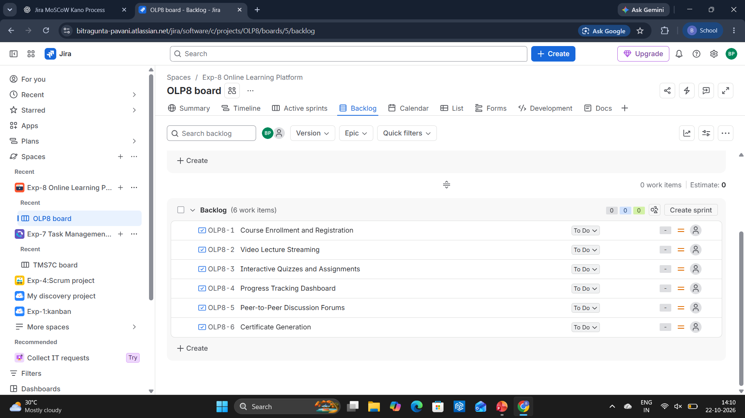
Figure 1: Backlog view with the six tasks of the Online Learning Platform
Issue | Task Name | Kano category | Status
OLP8-1 | Course Enrollment and Registration | Must-be | To Do
OLP8-2 | Video Lecture Streaming | Must-be | To Do
OLP8-3 | Interactive Quizzes and Assignments | Attractive | To Do
OLP8-4 | Progress Tracking Dashboard | Performance | To Do
OLP8-5 | Peer-to-Peer Discussion Forums | Performance | To Do
OLP8-6 | Certificate Generation | Attractive | To Do

Step 4: Check the default priority
Open the "List" tab. Jira shows the default priority "Medium" for every task, because the Kano categories have not been assigned yet.

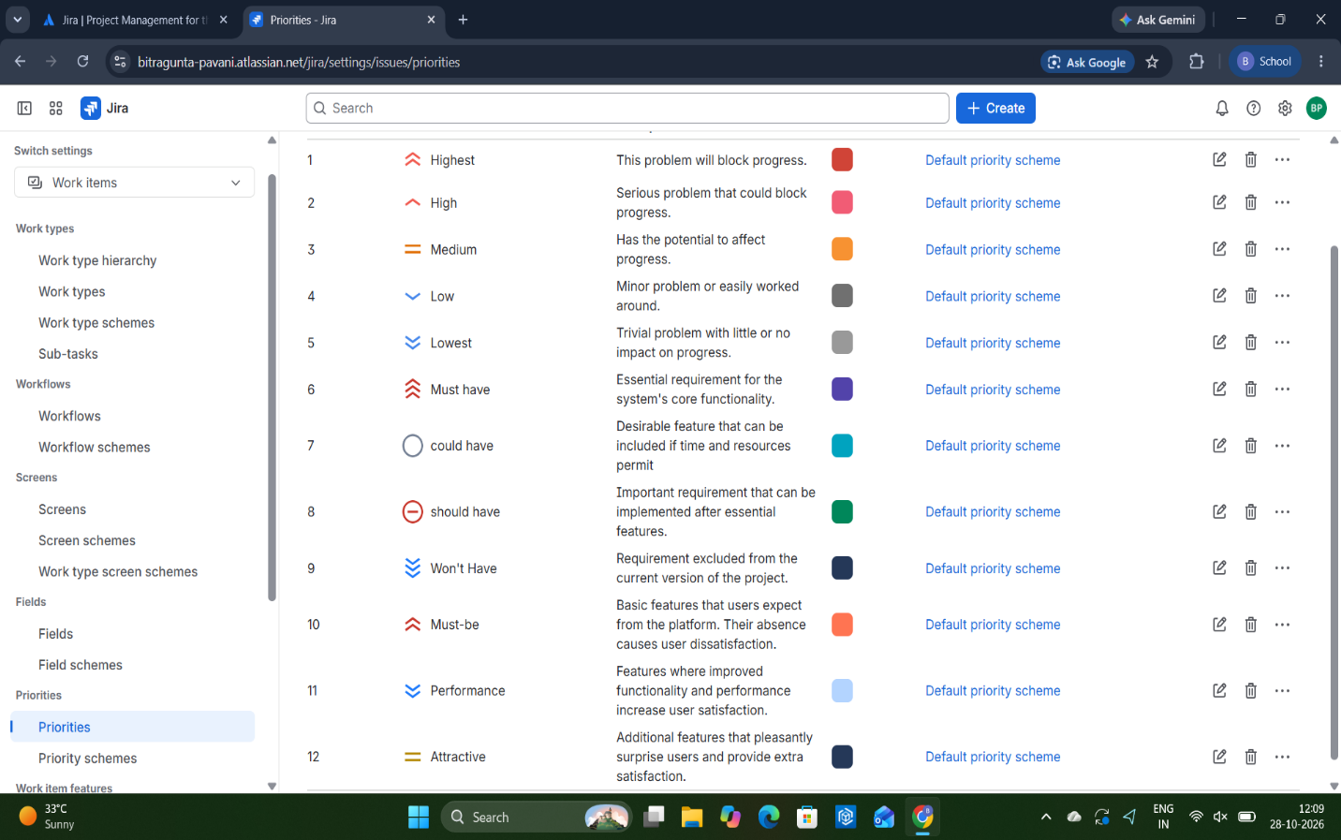

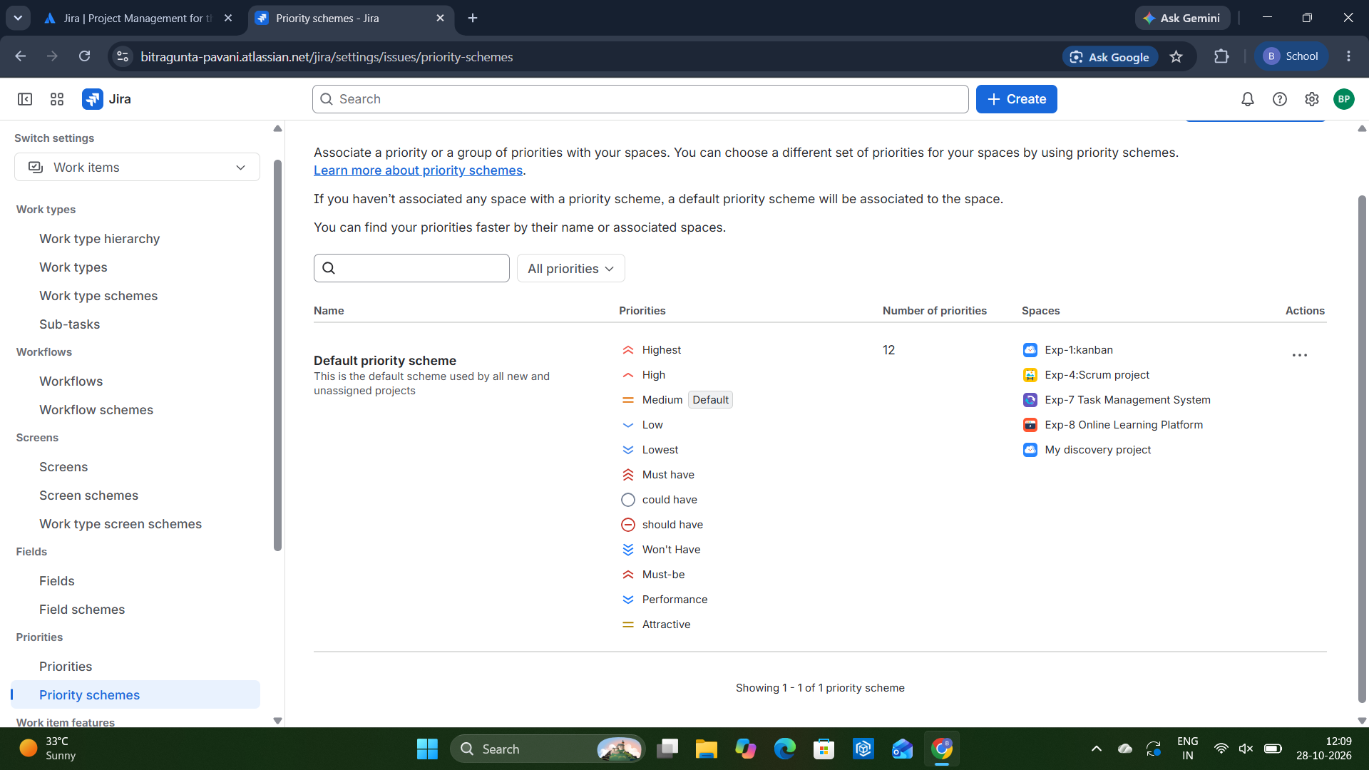
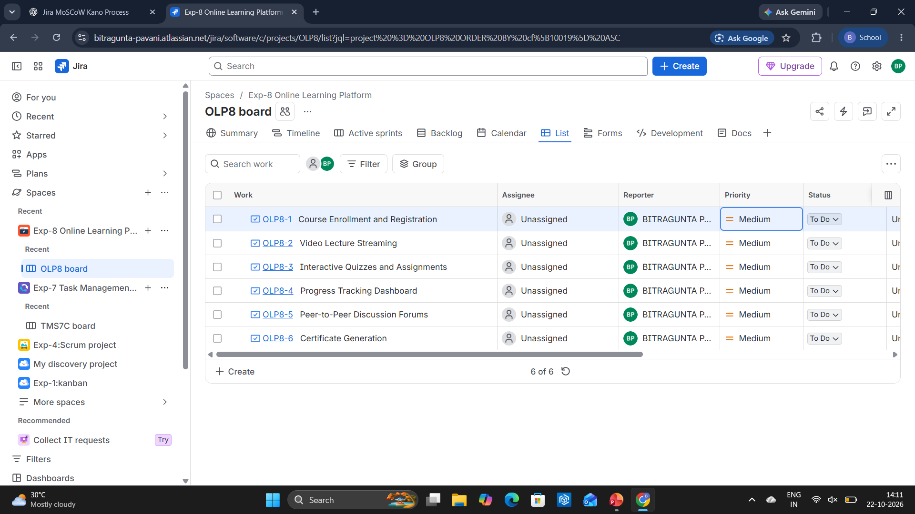
Figure 2: List view with the default Medium priority for all tasks

Step 5: Set the Kano categories as priorities
Open Settings, go to Work items and then Priorities, and set the priority names Must-be, Performance and Attractive. Then click the Priority column of each task in the List view and select its Kano category.
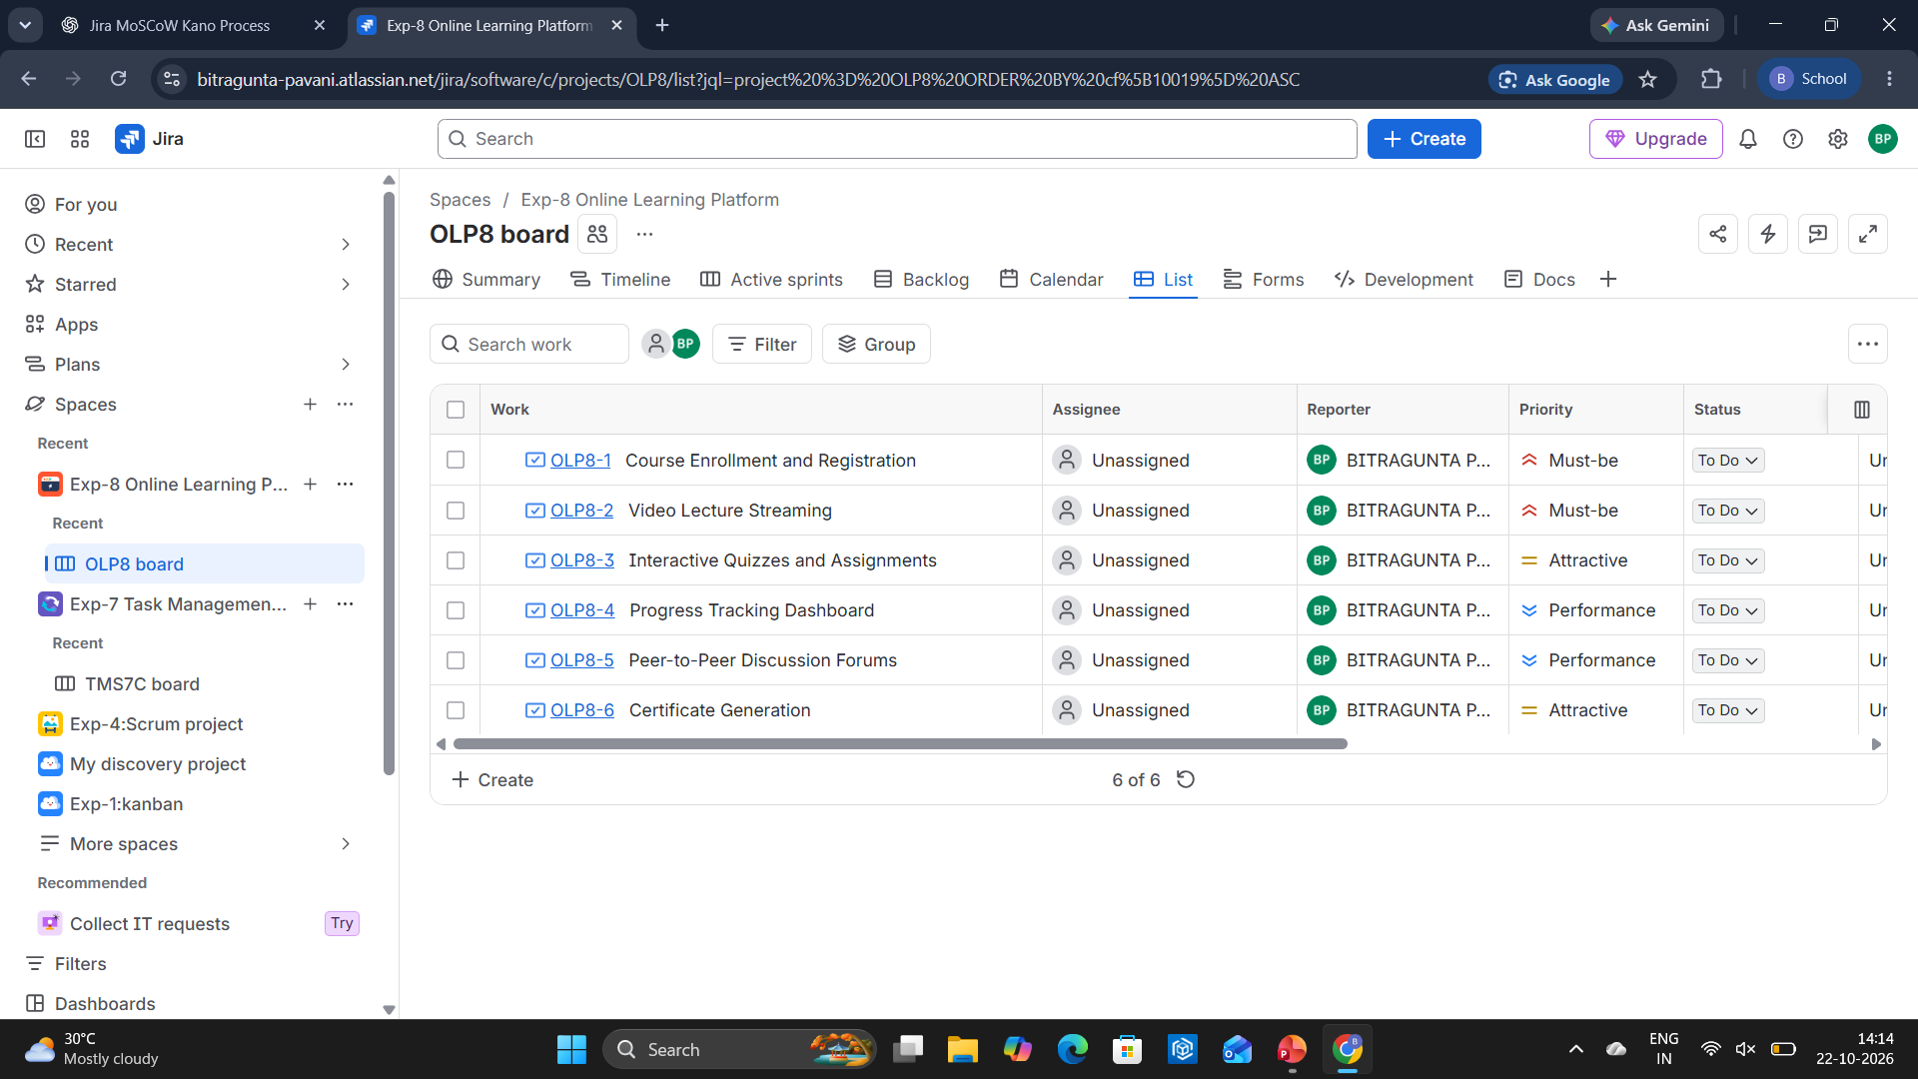
Figure 3: List view with the Kano categories assigned as priorities

Reason for the Categories
Task | Category | Reason
Course Enrollment and Registration | Must-be | Learners cannot use the platform without enrolling in courses.
Video Lecture Streaming | Must-be | Delivering lectures is the basic purpose of an online learning platform.
Interactive Quizzes and Assignments | Attractive | Makes learning more engaging, and learners do not expect it as a basic feature.
Progress Tracking Dashboard | Performance | The better the tracking, the more satisfied learners are.
Peer-to-Peer Discussion Forums | Performance | Better discussion support increases learner satisfaction.
Certificate Generation | Attractive | A pleasant extra that rewards learners for completing a course.

Category Summary
Kano category | Tasks | Number of tasks
Must-be | OLP8-1, OLP8-2 | 2
Performance | OLP8-4, OLP8-5 | 2
Attractive | OLP8-3, OLP8-6 | 2
Total |  | 6

Result
An Online Learning Platform project was created in Jira. Six main features were added as tasks and prioritized using the Kano model: two Must-be, two Performance and two Attractive features. The Kano categories appear in the Priority column of the List view.

